**Startup Failure Post-Mortems 2017 First Update (2/10/17)**

### Angel Sensor

Title: [Open source wearable Angel shuts down](http://www.mobihealthnews.com/content/open-source-wearable-angel-shuts-down)  
Title Link: <https://www.mobihealthnews.com/content/open-source-wearable-angel-shuts-down>

Product: [Angel Sensor](https://www.cbinsights.com/company/seraphim-sense)  
Product Link: <https://www.mobihealthnews.com/content/open-source-wearable-angel-shuts-down>

We’ve been through a really rough patch over these past months. We’ve experienced engineering and financing difficulties, downsized our R&D and fought many battles to keep the project alive.

# Angel Sensor

CONSUMER PRODUCTS & SERVICES | Consumer Electronics  
[angelsensor.com](https://angelsensor.com/)

## Stage

Dead | Dead

## Total Raised

## $460K

## Founded:

 2013

## About Angel Sensor

Angel Sensor is a flexible wristband that can be worn 24/7. Angel Sensor is the only wearable designed as an open platform for mobile health. Angel Sensor tracks heart rate, blood oxygen, skin temperature, steps, sleep quality, calories, acceleration, and orientation.

## Angel Sensor Headquarter Location

United States

## Open source wearable Angel shuts down

By Jonah Comstock December 02, 2016 03:25 pm

Title Link: <https://www.mobihealthnews.com/content/open-source-wearable-angel-shuts-down>

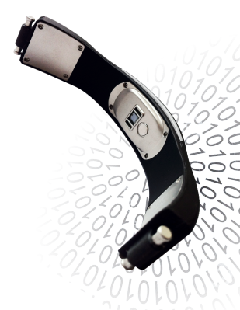

Angel, a company that has been working since 2013 on an open source wearable tracker that could be programmed for different use cases, has shut down the project and, likely, the company.

The company announced the news via a large banner **[on its website](http://angelsensor.com/)** reading "This project is no longer active". Angel executives did not respond to MobiHealthNews's request for an interview. Bob Troia, known as "Quantified Bob" in quantified self circles, spotted the announcement and posted about it on Twitter and on the Quantified Self forum.

"Well, looks like the Angel Sensor folks have (finally) officially thrown in the towel," **[he wrote](https://forum.quantifiedself.com/t/angelsensor-officially-rip/3138)**. "Not really a surprise, as they had gone silent for nearly a year after delivering their crowdfunded product over two years late. They did release code for their open-source SDK, and there is a community of developers who have forked it on GitHub3 to continue development. Too bad they gave up, as the promise of a truly open source wearable with an array of useful sensors is lacking in the QS space."

Angel completed a well-funded Indiegogo campaign in late 2013, raising $334,000 out of an original goal of $100,000. The wristband could measure pulse, temperature, activity and blood oxygen level and was aimed at researchers, hackers, and quantified selfers.

"Angel is the first device designed with developers in mind," the company wrote on its Indiegogo page. "Currently most trackers for fitness and health are built for use by a single proprietary app. We want to change that. We are opening up communication protocols, API/SDK and sensor data streams. Ultimately, this will mean more apps to choose from."

But, as is often the case, the company ran into a number of manufacturing problems. The company's last blog post, from April 2015, lays out some of these struggles.

"We’ve been through a really rough patch over these past months," the company wrote. "We’ve experienced engineering and financing difficulties, downsized our R&D and fought many battles to keep the project alive."

It's unclear whether all of the backers even received their devices. In addition, prior to shutting down, the company was taking pre-orders for both the original wearable and a second-generation device.

The open source nature of the product means that some of the researchers that had already begun to use the device should be able to continue, though they may run into trouble if they want to scale the project or replace a defective unit. For instance, a Spanish university launched a project **[using the Angel Sensor to detect epileptic seizures](https://web.ua.es/en/actualidad-universitaria/2016/noviembre16/7-13/ua-graduate-designs-the-first-app-to-detect-epileptic-seizures-in-children-suffering-from-acquired-brain-damage.html)** just last month.